Ernie Haase and Signature Sound
Christmas Tour coming to Finleyville PA

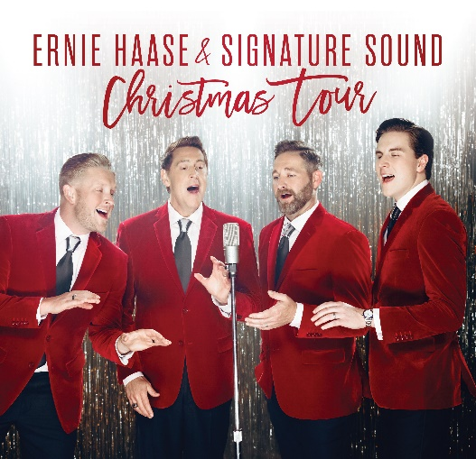
From singing on the hallowed stages of the Grand Ole Opry and Carnegie Hall, to delivering stirring renditions of the national anthem at NBA games and NASCAR events through the years, Ernie Haase & Signature Sound will return to the Pittsburgh area in Finleyville PA. Crossroads Ministries will once again host Ernie Haase and Signature sound for “A Jazzy Little Christmas” Concert and Dessert on Thursday and Friday- December 14 & 15, 2023 at 7:00 PM!
Their holiday collection, A Jazzy Little Christmas, landed in the Top 10 on Billboard’s Jazz Albums chart and was named among the “Best Christmas Albums of 2019” by the Los Angeles Times. In addition, 2022’s Decades of Love—a whopping 29-song set—showcases Ernie Haase & Signature Sound’s unique arrangements of some of the world’s most romantic standards, including “It Had To Be You,” “Blue Moon,” and “I’ll Be Seeing You.”
You are invited to come and enjoy, Grammy -nominated and GMA Dove Award-winning, Ernie Haase & Signature Sound. This Christmas Tour will be sure to get you in the Christmas spirit! Come and enjoy an evening filled with fun, laughter, Christmas music, and Dessert after the concert. Tickets include the concert as well as the dessert and are available now at www.crsmin.com
Come start your Christmas season with us! Crossroads is located at 81 Walter Long Road, Finleyville PA 15332. (about a 1 ½ mile south of Trax Farm.)

